**FCIS (Fully Convolutional Instance-aware Semantic Segmentation) Report**

# Results:

**1 image from original training set**

From Pretrained model

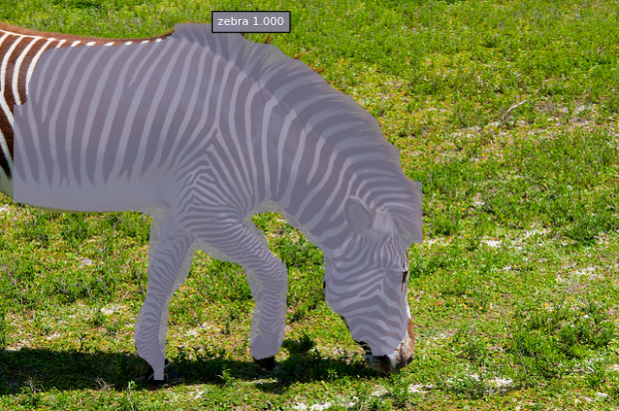

Epochs: 1000

Learning Rate: 0.0005

Threshold: 0.2

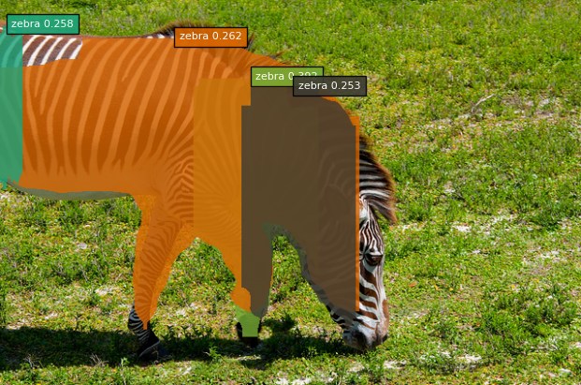

Epochs: 5000

Learning Rate: 0.0005

Threshold: 0.1

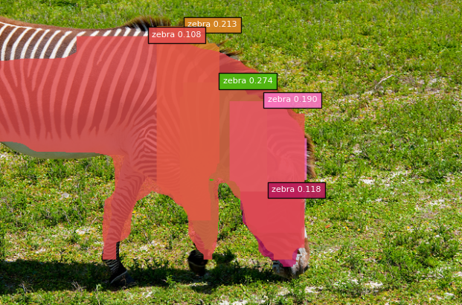

Epochs: 10000

Learning Rate: 0.005

Threshold: 0.0

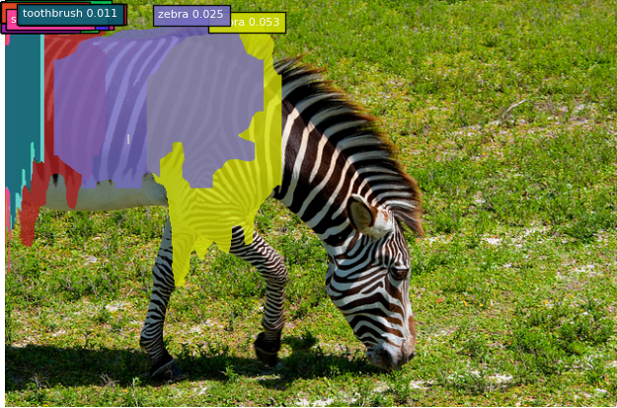

From ResNet paper: With an initial learning rate of 0.1, it starts converging (<90% error)after several epochs, but still reaches similar accuracy.

**1 image from PRISM set**

Epochs: 1000

Learning Rate: 0.0005

Threshold: 0.95

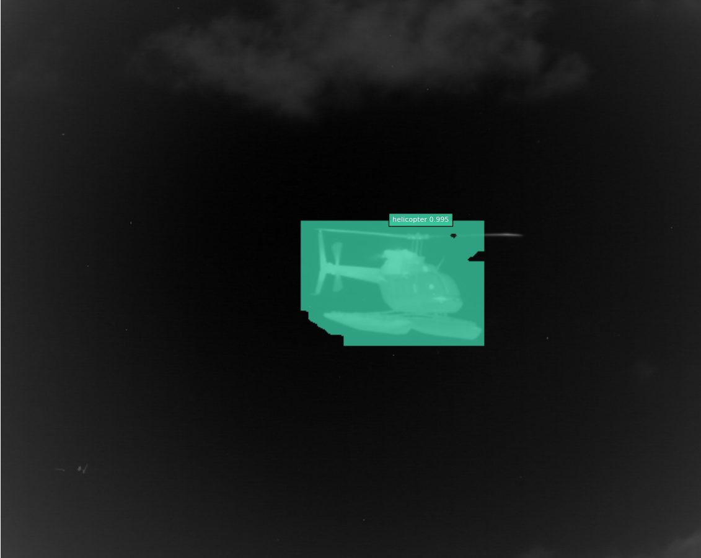

Threshold: 0.7

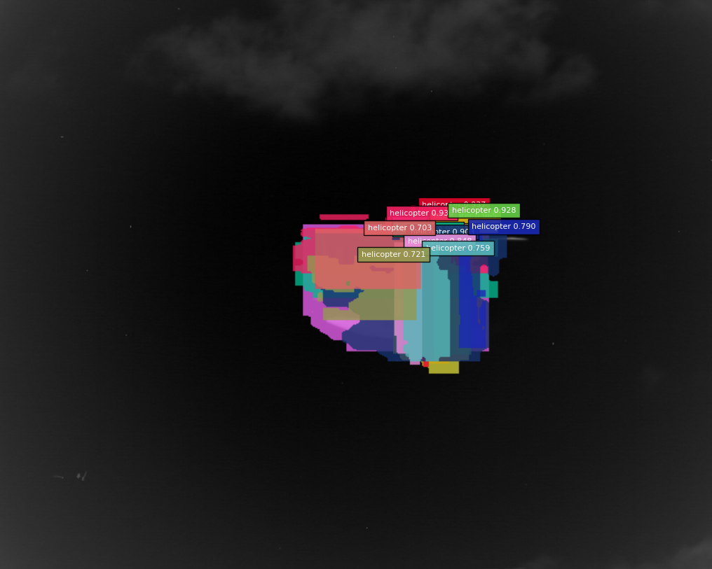

Epochs: 6000

Learning Rate: 0.0005

Threshold: 0.0

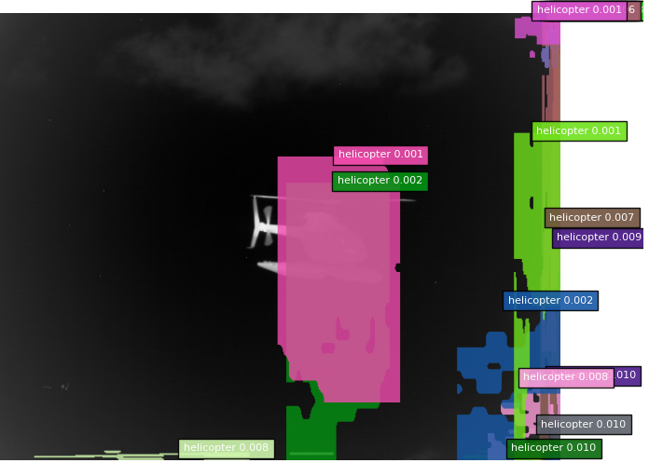

**Extracted animals from PRISM**

Epochs: 115

Learning Rate: 0.005

Threshold: 0.1

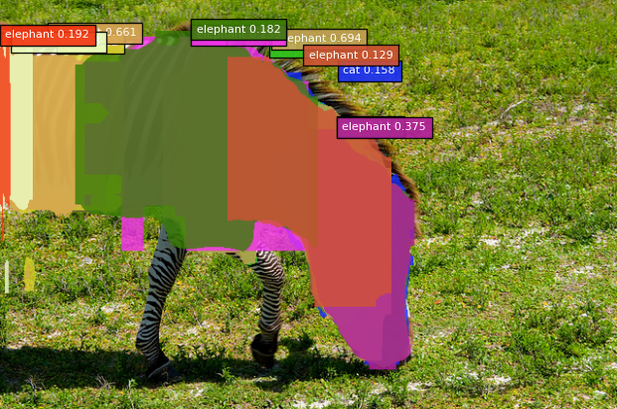

Threshold: 0.3

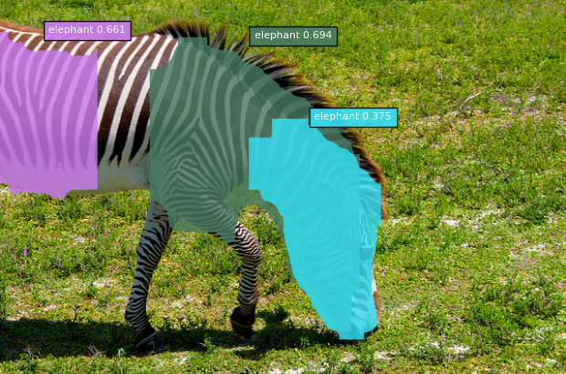

Threshold: 0.5

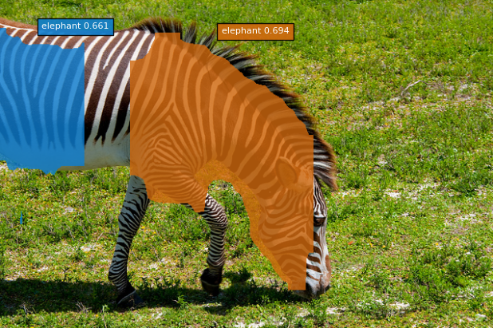

Epochs: 500

Learning Rate: 0.005

Threshold: 0.3

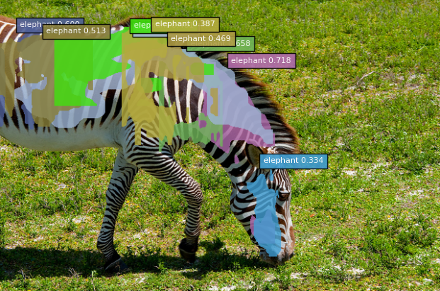

Threshold: 0.5

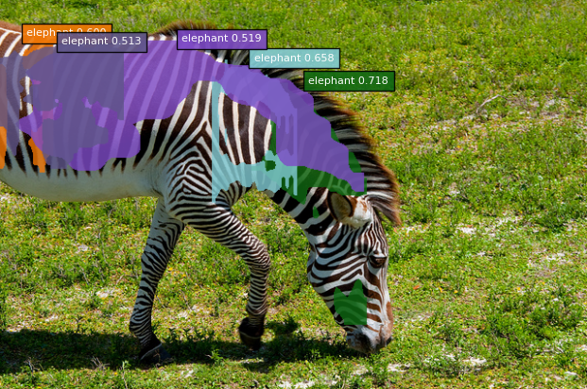

Next Steps:

* Finish current training
* Try different learning rates
* Try with PRISM